Microcystis aeruginosa (Wittrock) Kirchner 1898

Phylum: Cyanobacteriophyta
Class: Cyanophyceae
Order: Chroococcales

Habitat: planktonic, pelagic
Distinctive features: irregular 3D colony shape often with holes. Spherical cells, similar size or slightly larger than those of M. flos-aquae. Usually, both species co-occur.
Organization: colonial
Color: green or brown
Cell shape: sphere
Colony shape: irregular
Cell diameter (D): 2 – 5 μm, median: 3 μm (N=2500)
Cell biovolume: 4 – 65 μm³, median: 13 μm³
Biovolume equation: Sphere, V = 4/3 π (D/2)³
Cells per colony: 20-10000; median: 300
Colony diameter: 100-1000 μm

Morphological features:
Colonies are net-like (clathrate) with distinct holes or composed of sub-colonies with irregular outline, made of hundreds of irregularly gathered cells situated in a fine, colorless and diffuse mucilage with refractive outline. Cells are spherical, ~3 µm in diameter, with gas vesicles. Division in 3 perpendicular planes with a return development to the original spherical cell shape before the next succeeding division. Polymorphic species.
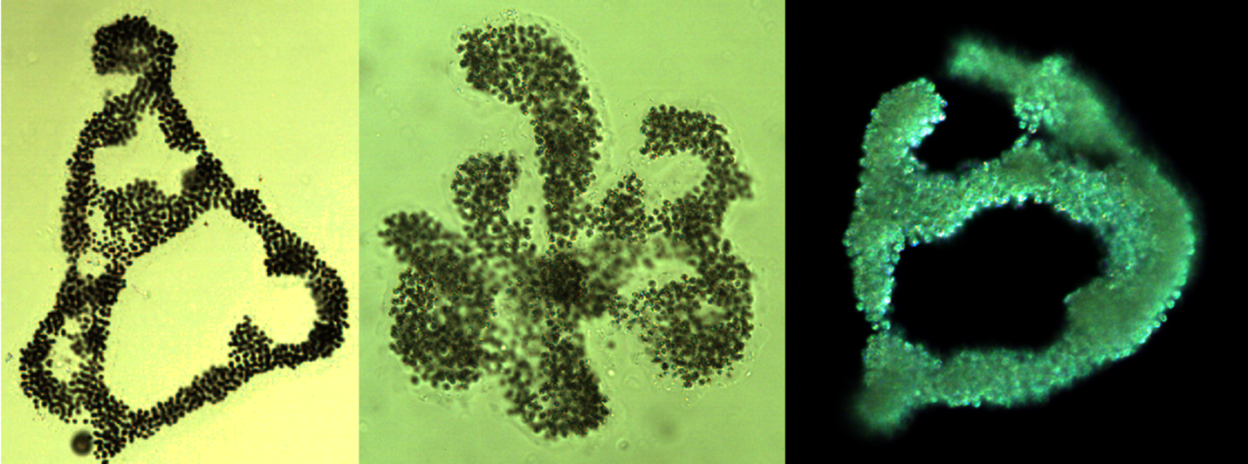
Plate 1. Microcystis aeruginosa from Lake Kinneret, showing the irregular net-like clathrate shape of colonies with holes. Photos by Alla Alster, 2006-2008.
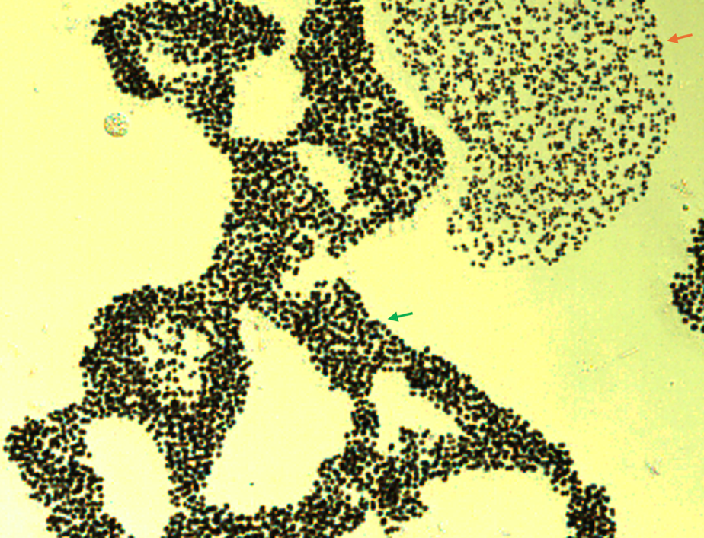
Plate 2. Microcystis aeruginosa (green arrow) and M. flos-aquae (red arrow) from Lake Kinneret. Photos by Alla Alster, 2006, Sta. A.
Ecology:
The species was not counted prior to 1996, when Analyst 5 began counting, probably because earlier M. aeruginosa and M. flos-aquae were considered as two forma of a single species. Microcystis aeruginosa is less abundant than M. flos-aquae, but usually both species co-occur (Plate 2). The species is more abundant from March to June, less abundant from August to December (Fig. 2a). The number of cells per colony ranges 100-2000 with no distinct annual pattern (Fig. 2b). Cell volume is usually 10-40 µm³, being largest from May to August (Fig. 2c).
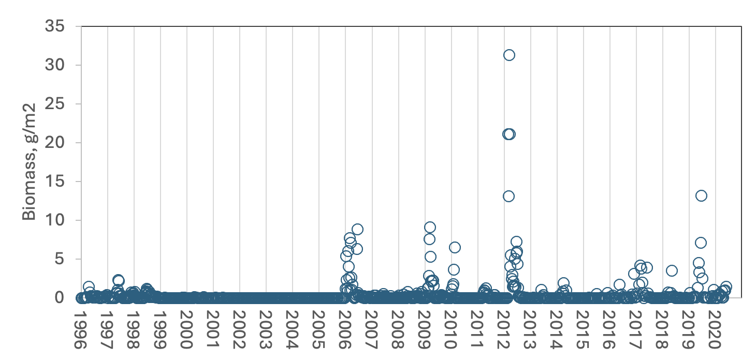
Figure 1. Time series of Microcystis aeruginosa depth-integrated biomass (g m⁻²), Lake Kinneret, 1996-2020.
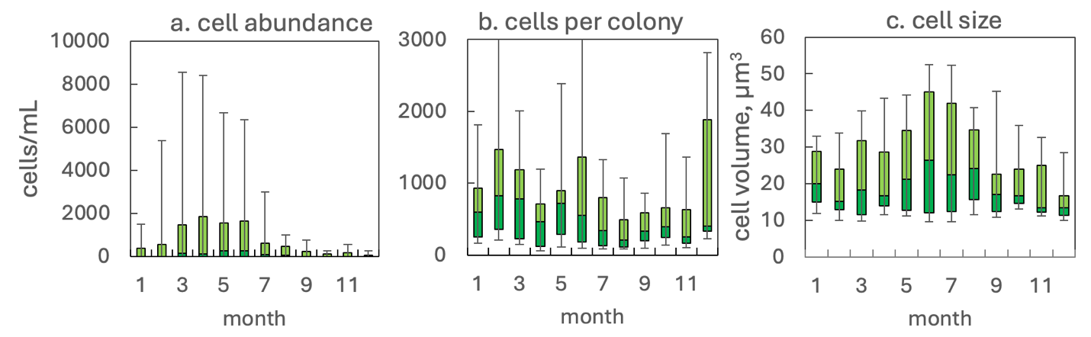
Figure 2. The annual pattern of Microcystis aeruginosa parameters, based on data for 1998-2020: (a) water column cell abundance; (b) number of cells per colony; (c) cell volume. Statistics shown are median – middle line; 25th to 75th percentiles – box content; 90th and 10th percentiles - top and bottom bars, respectively.
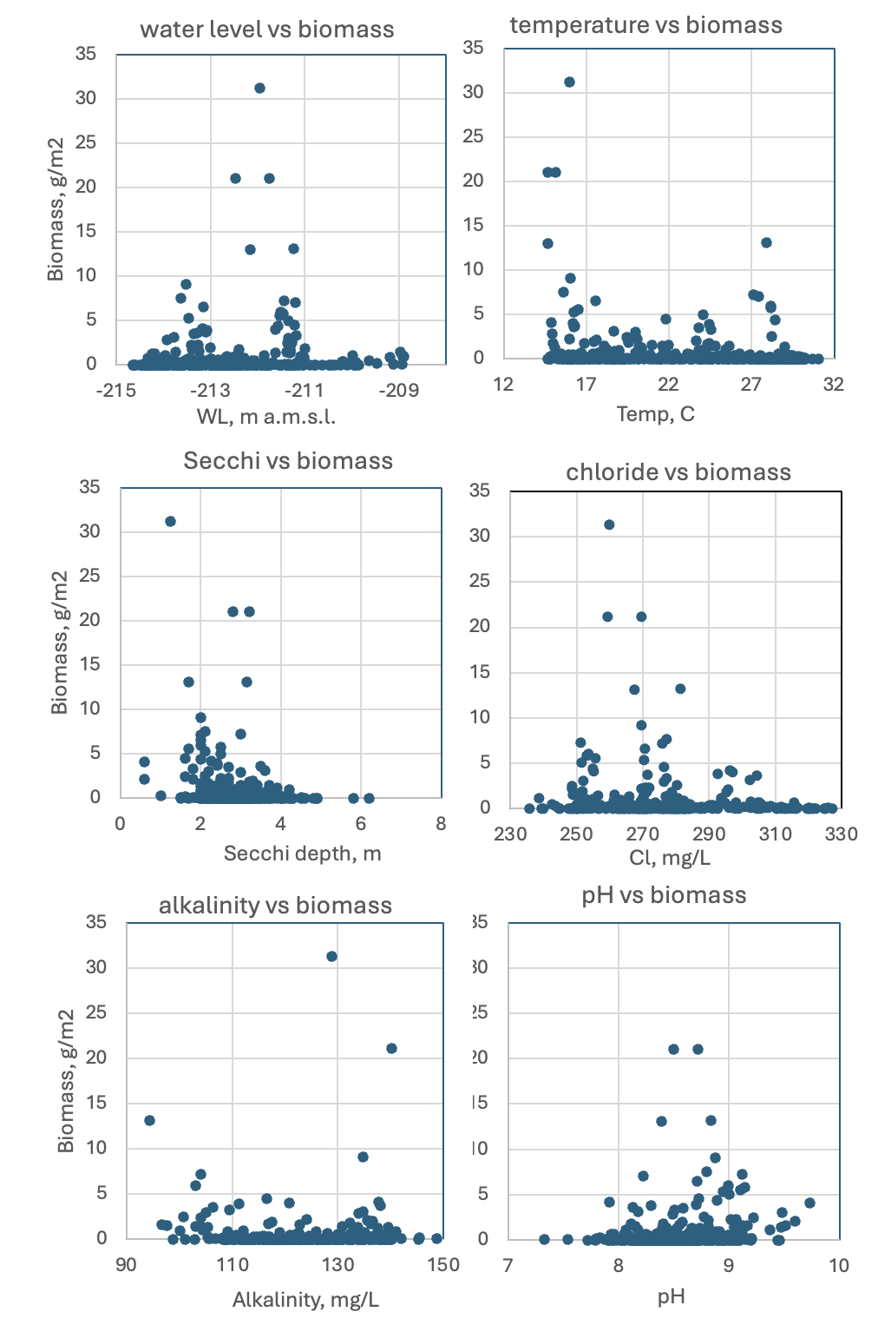
Fig. 3. Microcystis aeruginosa depth-integrated biomass (g wet weight m⁻²) vs. environmental parameters recorded at the site and time of sampling. Based on data for 1998-2020.
Physiological features:
Like other species of Microcystis, M. aeruginosa produces microcystins, that are hepatotoxins, highly toxic to humans and mammals. It regulates its position in the water column by sinking and floating, using its gas vacuoles to float and carbohydrate ballast to sink. During calm weather it accumulates at the surface to form scums. When cultured in liquid medium, Microcystis colonies break to single cells.

Environmental conditions:
M. aeruginosa biomass was indifferent to water temperature, pH, alkalinity, chloride, calcium and DON concentrations (Fig. 3). Biomass was higher when water level was lower than -211 m a.s.l., Secchi was < 3.2 m, z_{eu} < 10 m and nitrate < 0.4 mg L⁻¹.
Cite this record as:
Tamar Zohary, Alla Alster. [Date when Item was last updated]. Electronic publication. Israel Oceanographic & Limnological Research. [Date when last accessed].
Further reading:
Komárek J, Anagnostidis K. 1999. Cyanoprokaryota. 1. Chroococcales. In: Süßwasserflora von Mitteleuropa. Begründet von A. Pascher. Band 19/1. (Ettl H, Gärtner G, Heynig H, Mollenhauer D, Eds), pp. 1-548. Heidelberg & Berlin: Spektrum, Akademischer Verlag.
McGregor G, Fabbro LD, Lobegeiger JS. 2007. Freshwater planktic Chroococcales (Cyanoprokaryota) from North-Eastern Australia: a morphological evaluation. Nova Hedwigia 84(3/4): 299-331.

